**Lab Activity 9**

# **Subnetting a Class C Network**

**Objective:**

Subnetting is an important skill for anyone working in a subnetted network environment. As a network professional, you will be required to understand subnetting. Although subnetting will be covered in greater detail in later courses, it is important that students gain a solid foundational understanding in this class.

In this lab you will calculate the subnet mask, the subnet IDs, broadcast addresses and host ranges for a small class C network.

Once you have completed the lab, you will be able to:

* Subnet a class C network.

**Requirements:**

In order to complete this lab you will need:

* This lab will be done on paper.

**Activity:**

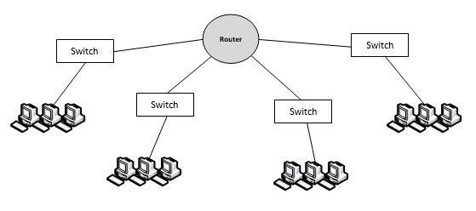In this activity you will calculate the subnet addresses, subnet masks, broadcast addresses, and host ranges for the class C network show below, with the Major Network Number of 192.168.54.0.

192.168.54.192

192.168.54.0

192.168.54.128

192.168.54.64

192.168.54.194

192.168.54.254

192.168.54.1

192.168.54.62

192.168.54.130 - 192.168.54.190

192.168.54.66 - 192.168.54.126

1. How many subnets are in the network?____4_____
2. What is the default subnet mask for a class C network?__255.255.255.0
3. Which octet will we be borrowing bits from?__4th___
4. Use the formula 2Y = # of subnets, where Y = the number of bits borrowed from the host portion. (Ex. 5 subnet bits would give you 25 = 32 subnets)
5. How many bits do you need to borrow from the host portion?__2_
6. How many bits does that leave you for host?__6__
7. Use the formula 2X – 2 = # of hosts, to determine how many hosts you will have on each subnet. X = the number of host bits.
8. How many hosts will you have on each subnet?___62___

(Ex. 5 host bits would give you 25 -2 = 30 hosts)

1. Given your answer in Step 3 above, calculate the subnet mask required to give you that many network bits.
2. Write the subnet mask in dotted decimal and binary.
   1. Binary: _11111111.11111111.11111111.11000000
   2. Decimal: ____255.255.255.192
3. Determine the multiplier by looking at the right-most bit borrowed in the subnet mask, and calculating the decimal value of that bit.
4. What is the multiplier? ____64_______
5. Using the above multiplier, determine the subnetwork addresses (subnet IDs): (Hint: Always start with 0)
   * Subnet 1:___192.168.54.0________
   * Subnet 2:___192.168.54.64________
   * Subnet 3:___192.168.54.128_______
   * Subnet 4:___192.168.54.192_______
6. The last address on any subnet is the broadcast address. What are the broadcast addresses for each subnet? (Hint: Subtract 1 from the next subnet ID)

| **Subnet ID** | **Broadcast Address** |
| --- | --- |
| 192.168.54.0 | **192.168.54.63** |
| 192.168.54.64 | **192.168.54.127** |
| 192.168.54.128 | **192.168.54.191** |
| 192.168.54.192 | **192.168.54.255** |

1. All of the addresses between the subnet ID and the broadcast address are your usable host addresses. What is the host address range for each subnet?

| **Subnet ID** | **Host Range** |
| --- | --- |
| 192.168.54.0 | **192.168.54.1 -192.168.54.62** |
| 192.168.54.64 | **192.168.54.66 -192.168.54.126** |
| 192.168.54.128 | **192.168.54.130 -192.168.54.190** |
| 192.168.54.192 | **192.168.54.194 -192.168.54.254** |

1. Label the network diagram, with the subnet IDs and the host ranges. Write the subnet ID next to the corresponding switch, and label each host range under the computers on each subnet.

**Deliverables:**

* Turn this completed document in.